006BC2744 - Day 21 (13 August 2026)

Home Tasks:

- What is the difference between Node.js and a traditional web server like Apache or Nginx?

Node.js is a JavaScript runtime used to execute application code and handle requests, while Apache/Nginx are primarily web servers/reverse proxies. Node.js is especially suited for dynamic, real-time and API-driven applications.

- Explain the event-driven architecture of Node.js.

Node.js uses an event-driven model, where operations generate events and callbacks/handlers respond to them. This allows the application to handle many requests without creating a separate thread for each request.

- How does the single-threaded model in Node.js handle concurrency?

Node.js runs JavaScript primarily on a single main thread, but handles I/O asynchronously using the event loop and underlying system/libuv facilities. This allows many I/O operations to progress concurrently without blocking the main thread.

- What is the role of the V8 engine in Node.js?

V8 is Google's JavaScript engine, also used by Chrome, that executes JavaScript code. Node.js embeds V8 and provides additional APIs for files, networking, processes, etc.

- Why is Node.js considered non-blocking?

Node.js starts I/O operations asynchronously instead of waiting for them to finish. Once the operation completes, its callback or promise continuation is processed, allowing other work to continue meanwhile.

- What is the difference between callbacks, promises, and async/await in Node.js?

Callbacks run when an asynchronous operation completes, while Promises represent a future result and support .then()/.catch(). async/await provides cleaner, synchronous-looking syntax for working with Promises.

- How does the event loop work, and what are its phases?

The event loop repeatedly checks for completed asynchronous work and executes its callbacks. Major phases include timers, pending callbacks, poll, check (setImmediate()), and close callbacks.

- What is the difference between process.nextTick() and setImmediate()?

process.nextTick() runs its callback after the current operation finishes, before the event loop continues. setImmediate() runs during the event loop's check phase, generally after the poll phase.

- How does Node.js handle I/O operations asynchronously?

Node.js delegates many I/O operations to the operating system or libuv's worker pool, rather than blocking the JavaScript thread. When the operation completes, the result is queued for processing by the event loop.

- How does the require() function work internally?

In CommonJS, require() loads a module, resolves its path, executes the module code, and returns its module.exports. Node.js caches loaded modules, so subsequent require() calls normally reuse the cached module.

- What is the purpose of package.json and package-lock.json?

package.json contains project metadata, scripts, and dependency requirements. package-lock.json records the exact dependency versions and dependency tree, helping ensure reproducible installations.

- Explain the difference between dependencies and devDependencies in npm.

dependencies are packages required when the application runs, such as Express. devDependencies are packages mainly needed during development/testing/building, such as ESLint, Jest, or testing tools.

Task 1: Create a common js module in nodejs to do some arithmetic operations.
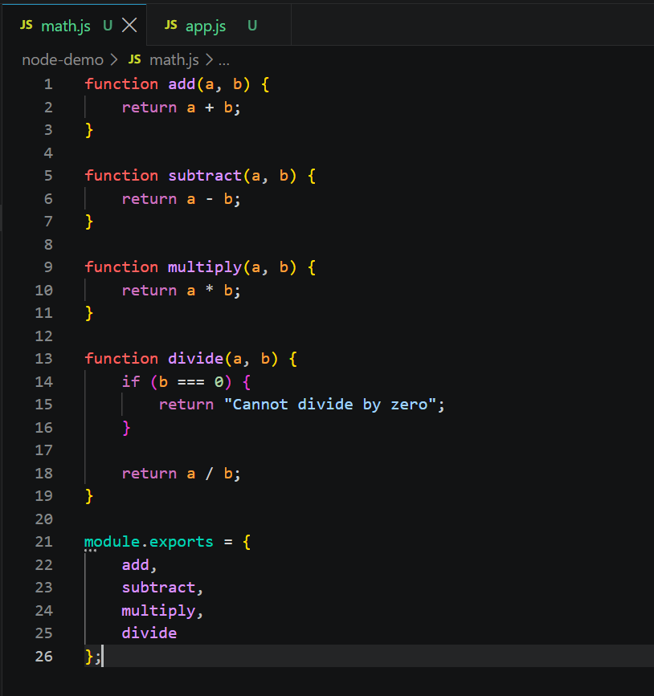
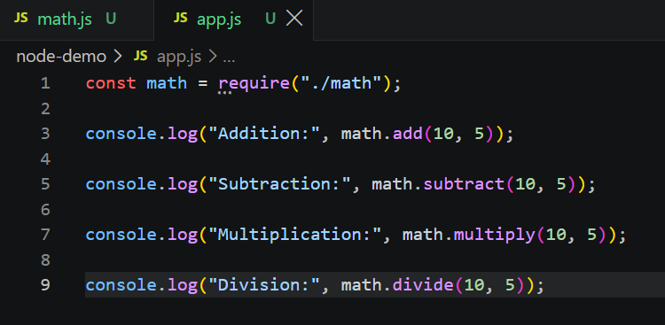

Task 2: Create the same task 1 code using ecmascript.

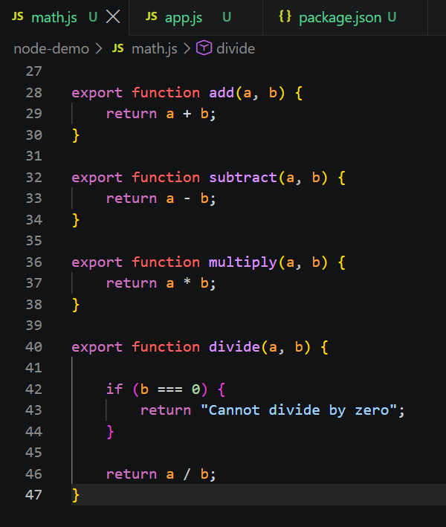

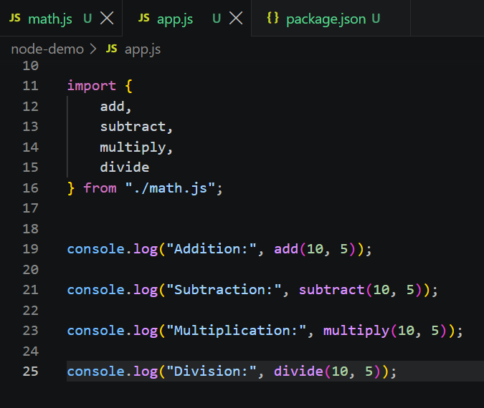

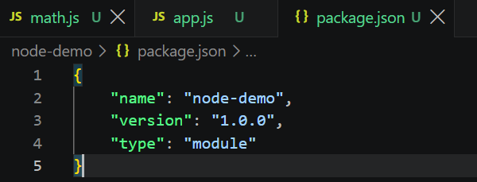

Task 4: Given 2 files app.js and home.ejs
Can you let me know what we are doing in this code.. Give comments for this code in your document.
app.js
// app.js

const express = require('express')
const bodyParser = require('body-parser')
const notes = [{
noteId: 1,
noteContent: "Hey, Prasunamba you can add your important notes here."
}
]

const app = express()

app.set('view engine', 'ejs')

app.use(bodyParser.json());
app.use(bodyParser.urlencoded({
extended: true
}))

app.get("/", function (req, res) {
res.render("home", {
data: notes
})
})

app.post("/", (req, res) => {
const noteContent = req.body.noteContent
const noteId = notes.length + 1;

notes.push({
noteId: noteId,
noteContent: noteContent
})

res.render("home", {
data: notes
})
})

app.post('/update', (req, res) => {
var noteId = req.body.noteId;
var noteContent = req.body.noteContent;

notes.forEach(note => {
if (note.noteId == noteId) {
note.noteContent = noteContent;
}
})
res.render("home", {
data: notes
})
})

app.post('/delete', (req, res) => {
var noteId = req.body.noteId;

var j = 0;
notes.forEach(note => {
j = j + 1;
if (note.noteId == noteId) {
notes.splice((j - 1), 1)
}
})

res.render("home", {
data: notes
})
})

app.listen(3000, (req, res) => {
console.log("App is running on port 3000")
})

home.ejs
<!DOCTYPE html>
<html>

<head>
<title>Note Keeper</title>
</head>

<body>
<h1>Note Keeper</h1>

<div style="display: flex;">

<% data.forEach(element=> { %>

<form action="/update" method="post">
<input type="number" style="display: none;"
name="noteId" value="<%= element.noteId %>">
<textarea type="text" rows="6" cols="30"
placeholder="Type Here..." name="noteContent"
value="<%= element.noteContent %>">
<%= element.noteContent %></textarea>
<br>
<button type="submit">Update</button>
</form>

<form action="/delete" method="post">
<input type="number" style="display: none;"
name="noteId" value="<%= element.noteId %>">
<button type="submit"
style="margin: 0px 4px;">&#10005</button>
</form>
<% }) %>
</div>

<h1>Add Note</h1>
<form action="/" method="post">
<input type="number" style="display: none;"
name="noteId">
<textarea type="text" rows="6" cols="30"
placeholder="Type Here..."
name="noteContent"></textarea>
<br>
<button type="submit">Add</button>
</form>
</body>

</html>

Task 5:
- Import all the required modules like express…
- Initialize the express app
- Create a async function for getting weather.
  - Use await Fetch for `https://api.openweathermap.org/data/2.5/weather?q=${city}&appid=${process.env.WEATHER_KEY}&units=metric`
And assign to response.
  - Now convert response to json..
  - Then return weather info like city , forecast. Temp…etc..
  - Iff any error catch it in catch block
- Next call the web server route.
Like sample
app.get('/weather', async (req, res) => {
const city = req.query.city || "Bengaluru"; // default city
const weatherData = await getWeather(city); // async call
res.json(weatherData); // send JSON response
});

- Finally start the server.
Task 6: What is Mongoose? What are the key features?Why do we use them ?

Mongoose is an ODM (Object Data Modeling) library for Node.js that makes working with MongoDB easier. It provides schemas, models, validation, middleware, and query helpers, giving MongoDB data a more structured approach.

Task 7: Is this statement true or false? Mongoose acts as a bridge between Node.js and MongoDB, giving you a structured way to manage your data.

True. Mongoose acts as a bridge between Node.js applications and MongoDB, allowing developers to define schemas and models and interact with MongoDB using JavaScript objects.

Task 8: Now in your project
Import mongoose
Connect to mongodb
Let's define a schema..

const mongoose = require("mongoose");

// 1. Connect to MongoDB
mongoose.connect("mongodb://127.0.0.1:27017/bankingDB")
.then(() => {

console.log("Connected to MongoDB");

})
.catch((error) => {

console.error("MongoDB connection error:", error);

});

// 2. Define Schema

const userSchema = new mongoose.Schema({

name: String,

age: Number,

email: {
type: String,
required: true
}

});

// 3. Create Model

const User = mongoose.model(
"User",
userSchema
);

// 4. Insert a document

const newUser = new User({

name: "Prasunamba",

age: 30,

email: "prasun@example.com"

});

// 5. Save the document

newUser.save()
.then(() => {

console.log("User saved successfully!");

})
.catch((error) => {

console.error("Error saving user:", error);

});

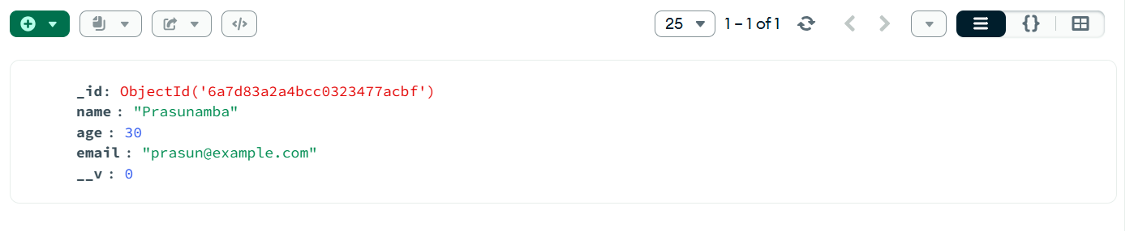

Task 9:
Create a project structure like this 👍 similar ..

Install dependencies:
In bash
npm install express mongoose bcryptjs jsonwebtoken jest supertest

Start mongo
Start server.. src/index.js
Run tests.. Npm test

index.js
// src/index.js
const express = require('express');
require('./db/mongoose'); // Ensures MongoDB connection is established
const userRouter = require('./routers/user');
const taskRouter = require('./routers/task');

const app = express();
const port = process.env.PORT || 3000;

// Middleware to parse JSON requests
app.use(express.json());

// Register routers
app.use(userRouter);
app.use(taskRouter);

// Start server
app.listen(port, () => {
console.log(`🚀 Server running on port ${port}`);
});

module.exports = app; // Export for testing with Jest & Supertest

Step 1:
File: src/db/mongoose.js
Create mongodb connection with promises.. (success or failed connection)
Juz for reference only ..
const mongoose = require('mongoose');

// Connect to MongoDB using Promises
mongoose.connect('mongodb://127.0.0.1:27017/task-app-api', {
useNewUrlParser: true,
useUnifiedTopology: true
})
.then(() => console.log("✅ Connected to MongoDB"))
.catch((error) => console.error("❌ Connection error:", error));

Step 2:
File: src/models/user.js
Create user schema
Ensure hash password before u save
Generate JWT token as well
Juz fyi.. Only
const mongoose = require('mongoose');
const bcrypt = require('bcryptjs');
const jwt = require('jsonwebtoken');

// User schema
const userSchema = new mongoose.Schema({
name: { type: String, required: true },
email: { type: String, unique: true, required: true },
password: { type: String, required: true, minlength: 6 },
tokens: [{ token: { type: String, required: true } }]
}, { timestamps: true });

// Hash password before saving
userSchema.pre('save', async function(next) {
const user = this;
if (user.isModified('password')) {
user.password = await bcrypt.hash(user.password, 8);
}
next();
});

// Generate JWT token
userSchema.methods.generateAuthToken = async function() {
const user = this;
const token = jwt.sign({ _id: user._id.toString() }, 'secretkey');
user.tokens = user.tokens.concat({ token });
await user.save();
return token;
};

const User = mongoose.model('User', userSchema);
module.exports = User;

Step 3:
File: src/models/task.js
In this
define the Task model using Mongoose, which acts as the blueprint for how tasks are stored and managed in MongoDB.

Schema Definition: It specifies the structure of a Task document (fields like description, completed, createdAt, updatedAt).
Validation Rules: Ensures data integrity (e.g., description must be a string, completed defaults to false).
Middleware Hooks: Can include pre/post-save logic (e.g., timestamps, validation).
Model Export: Makes the Task model available to controllers and services for CRUD operations.
Juz fyi.. Only..
const mongoose = require('mongoose');

const taskSchema = new mongoose.Schema({
description: { type: String, required: true, trim: true },
completed: { type: Boolean, default: false },
owner: { type: mongoose.Schema.Types.ObjectId, required: true, ref: 'User' }
}, { timestamps: true });

const Task = mongoose.model('Task', taskSchema);
module.exports = Task;

Step 4:
File: src/middleware/auth.js
U know what to do….. Here give authentication
Juz fyi only..
const jwt = require('jsonwebtoken');
const User = require('../models/user');

const auth = async (req, res, next) => {
try {
const token = req.header('Authorization').replace('Bearer ', '');
const decoded = jwt.verify(token, 'secretkey');
const user = await User.findOne({ _id: decoded._id, 'tokens.token': token });

if (!user) throw new Error();

req.token = token;
req.user = user;
next();
} catch (e) {
res.status(401).send({ error: 'Please authenticate.' });
}
};

module.exports = auth;

Step 5:then comes
File: src/routers/task.js
Create a task
Filter them .. give pagination, sorting.
const express = require('express');
const Task = require('../models/task');
const auth = require('../middleware/auth');
const router = new express.Router();

// Create Task
router.post('/tasks', auth, async (req, res) => {
const task = new Task({ ...req.body, owner: req.user._id });
try {
await task.save();
res.status(201).send(task);
} catch (e) {
res.status(400).send(e);
}
});

// Get Tasks with filtering, pagination, sorting
// Example: /tasks?completed=true&limit=5&skip=0&sortBy=createdAt:desc
router.get('/tasks', auth, async (req, res) => {
const match = {};
const sort = {};

if (req.query.completed) {
match.completed = req.query.completed === 'true';
}

if (req.query.sortBy) {
const parts = req.query.sortBy.split(':');
sort[parts[0]] = parts[1] === 'desc' ? -1 : 1;
}

try {
await req.user.populate({
path: 'tasks',
match,
options: {
limit: parseInt(req.query.limit),
skip: parseInt(req.query.skip),
sort
}
});
res.send(req.user.tasks);
} catch (e) {
res.status(500).send();
}
});

module.exports = router;

user.js –

const request = require('supertest');
const app = require('../index');
const User = require('../models/user');

beforeEach(async () => {
await User.deleteMany();
});

test('Should signup a new user', async () => {
await request(app).post('/users').send({
name: 'Test User',
email: 'test@example.com',
password: 'MyPass777'
}).expect(201);
});

Step 6:
Now test them with JEST and supertest
File: src/tests/user.test.js
Write test cases..
For user and task…
user.test.js

const request = require('supertest');
const app = require('../index');
const User = require('../models/user');

beforeEach(async () => {
await User.deleteMany();
});

test('Should signup a new user', async () => {
await request(app).post('/users').send({
name: 'Test User',
email: 'test@example.com',
password: 'MyPass777'
}).expect(201);
});

task.test.js
const request = require('supertest');
const app = require('../index');
const Task = require('../models/task');

beforeEach(async () => {
await Task.deleteMany();
});

test('Should create task for user', async () => {
await request(app)
.post('/tasks')
.set('Authorization', `Bearer ${userOneToken}`)
.send({ description: 'Test task' })
.expect(201);
});

Here is the postman.. If you want to refer
Save this as TaskApp.postman_collection.json and import into Postman:
json
{
"info": {
"name": "Task App API",
"_postman_id": "12345-67890-abcdef",
"description": "Collection for Task App with Users & Tasks",
"schema": "https://schema.getpostman.com/json/collection/v2.1.0/collection.json"
},
"item": [
{
"name": "User Signup",
"request": {
"method": "POST",
"header": [],
"body": {
"mode": "raw",
"raw": "{\n \"name\": \"Test User\",\n \"email\": \"test@example.com\",\n \"password\": \"MyPass777\"\n}"
},
"url": {
"raw": "http://localhost:3000/users",
"protocol": "http",
"host": ["localhost"],
"port": "3000",
"path": ["users"]
}
}
},
{
"name": "User Login",
"request": {
"method": "POST",
"header": [],
"body": {
"mode": "raw",
"raw": "{\n \"email\": \"test@example.com\",\n \"password\": \"MyPass777\"\n}"
},
"url": {
"raw": "http://localhost:3000/users/login",
"protocol": "http",
"host": ["localhost"],
"port": "3000",
"path": ["users", "login"]
}
}
},
{
"name": "Get Profile",
"request": {
"method": "GET",
"header": [
{ "key": "Authorization", "value": "Bearer {{token}}" }
],
"url": {
"raw": "http://localhost:3000/users/me",
"protocol": "http",
"host": ["localhost"],
"port": "3000",
"path": ["users", "me"]
}
}
},
{
"name": "Create Task",
"request": {
"method": "POST",
"header": [
{ "key": "Authorization", "value": "Bearer {{token}}" }
],
"body": {
"mode": "raw",
"raw": "{\n \"description\": \"Finish Node.js project\"\n}"
},
"url": {
"raw": "http://localhost:3000/tasks",
"protocol": "http",
"host": ["localhost"],
"port": "3000",
"path": ["tasks"]
}
}
},
{
"name": "Get Tasks (Filter, Sort, Paginate)",
"request": {
"method": "GET",
"header": [
{ "key": "Authorization", "value": "Bearer {{token}}" }
],
"url": {
"raw": "http://localhost:3000/tasks?completed=false&limit=5&skip=0&sortBy=createdAt:desc",
"protocol": "http",
"host": ["localhost"],
"port": "3000",
"path": ["tasks"],
"query": [
{ "key": "completed", "value": "false" },
{ "key": "limit", "value": "5" },
{ "key": "skip", "value": "0" },
{ "key": "sortBy", "value": "createdAt:desc" }
]
}
}
}
]
}

